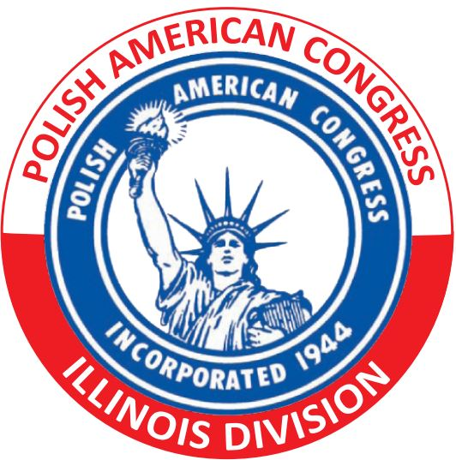Polish American Congress – Illinois Division
Individual Membership Application

PLEASE TYPE OR PRINT  CLEARLY  (All fields are required.) |  | PLEASE RETURN THE APPLICATION TO:  POLISH AMERICAN CONGRESS - IL DIVISION  110 W. Higgins Rd., Unit 2  Park Ridge, IL 60068 |  | Contact …  Phone: 847-825-6222  Email: pacil@sbcglobal.net
Date
Mr, Mrs, Ms, Miss, Dr (circle one)

Last Name First Name Initial(s)

Address (Nr., Street, City, State, Zip Code)
Home Phone | Mobile Phone |  | Business Phone
Email Address ( - check this box if NEW since last form submission) |  |  | U.S. Residency Status (check as applicable)  Citizen… By Birth By Naturalization | Permanent Resident
What languages do you speak? Polish English Other (specify) __________________________________________

What Polish-American organizations do/did you belong to? Specify if you hold/held office in said organization/s.

Dues payment enclosed (check one): Personal Check Cash Money Order
( Member $50.00 / Student Member $25.00 )
PLEASE ATTACH BRIEF BIOGRAPHY
If applicable, please emphasize your personal contributions to Polish organization/s
As required by the PAC-IL Bylaws, membership of the above applicant is recommended by current PAC member:

(1) ___________________________________________________________  Signature Date  ____________________________________________________________  Full Name  ____________________________________________________________  Address |  |  | (2) ___________________________________________________________  Signature Date  ____________________________________________________________  Full Name  ____________________________________________________________  Address
Applicant’s Signature _________________________________________ Date ______________________________________________________

Office Use Only:
The PAC State of Illinois Division _____ Recommends / _____Does not recommend this applicant for individual membership in the PAC:

Signature __________________________________ Position _________________________________ Date ____________________
The PAC National Executive Committee _____ Recommends / _____Does not accept this applicant for individual membership in the PAC:

Signature __________________________________ Position _________________________________ Date ____________________
Ver: 2/2019

